SESSION — ACTIVITY (15-20 MIN) • STUDENT HANDOUT • SLOT C
Visualization Matching Game
R.No: 1 Reg. No: 192524157 Name: A Lokesh Kumar
Each chart on the left (A-J) matches exactly one description on the right (1-10). Write the matching number next to each letter's blank.
A. | 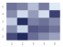 | 1. 4  Shows how a cumulative total changes over time
B. |  | 2. 2  Shows part-to-whole composition across categories
C. | 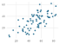 | 3. 5  Shows how a value changes over time
D. | 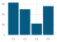 | 4. 10  Shows magnitude across two categories using color intensity
E. | 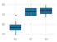 | 5. 6  Shows the relationship between two continuous variables
F. | 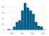 | 6. 8  Compares distributions across groups and highlights outliers
G. | 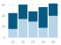 | 7. 9  Shows three variables at once using position and size
H. | 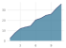 | 8. 1  Shows the distribution of a single continuous variable
I. | 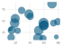 | 9. 7  Shows how parts contribute to a whole
J. | 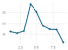 | 10. 3  Compares amounts across separate categories

